-22AIE203-  
Data structures and algorithms -2

**Name: Girish S Roll No.: AM.EN.U4AIE22044**

# ASSIGNMENT 2 – DIJKSTRA’S ALGORITHM

--------------------------------------------------------------------------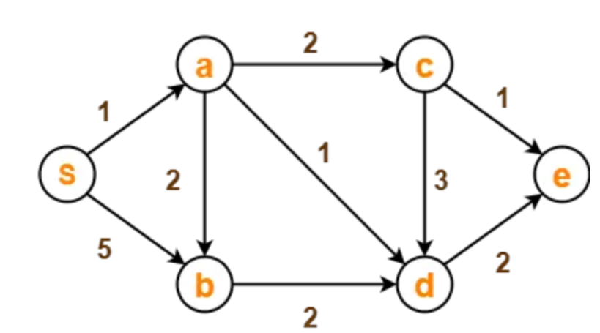



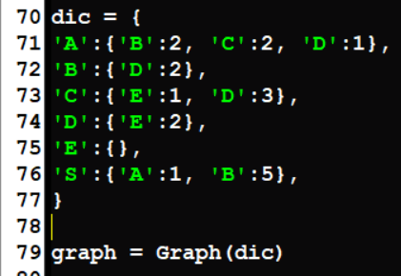

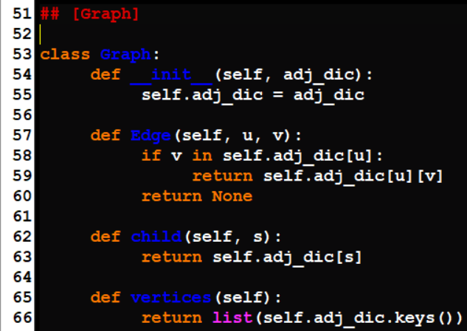

1. **Perform Dijkstra’s Algorithm on the given Graph using Adjacency matrix or Adjacency list**



